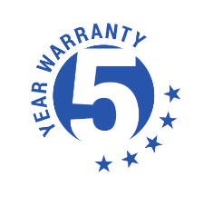
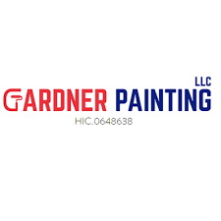

LIMITED WARRANTY

Gardner Painting LLC warrants labor and materials for a period of five (5) years. If paint failure occurs such as flaking, peeling, cracking or blistering, we will supply labor and materials to correct the condition without cost with limited exceptions. Doors painted or stained are covered by a one-year warranty. This warranty is in lieu of all other warranties expressed or implied. Our responsibility is limited to correcting the condition above.
This warranty excludes, and in no event Gardner Painting LLC be responsible for consequential or incidental damages caused by accident or abuses, settlement or moisture; i.e. cracks caused by expansion and/or contraction. Coating failures caused by vandalism, fire, home altercations, structural changes, rust, rotting wood, hail, tornado, act of God, or water damage caused by roof leaks, breakdown of previously applied coatings, inner coat peeling between existing coating, weakened or inferior substrates, and paint failure or any horizontal surfaces and decks, patios or flooring are not covered by this guarantee.
To redeem this warranty contact Gardner Painting LLC within five years of the project completion date to schedule a consultation. Gardner Painting LLC will inspect the issue, and at our sole discretion determine the appropriate steps necessary to remedy the situation. Gardner Painting LLC will repair only the defective coating and not areas or substrates not warranted or consequential damage.
This warranty is full transferrable.

